How to install the Windows Assessment Toolkit & the Windows Performance Toolkit

1. Download and install the Windows Assessment and Deployment Kit (Windows ADK) for Windows 10, version 1903 (and 1909) from <https://docs.microsoft.com/en-us/windows-hardware/get-started/adk-install>
2. Run adksetup.exe

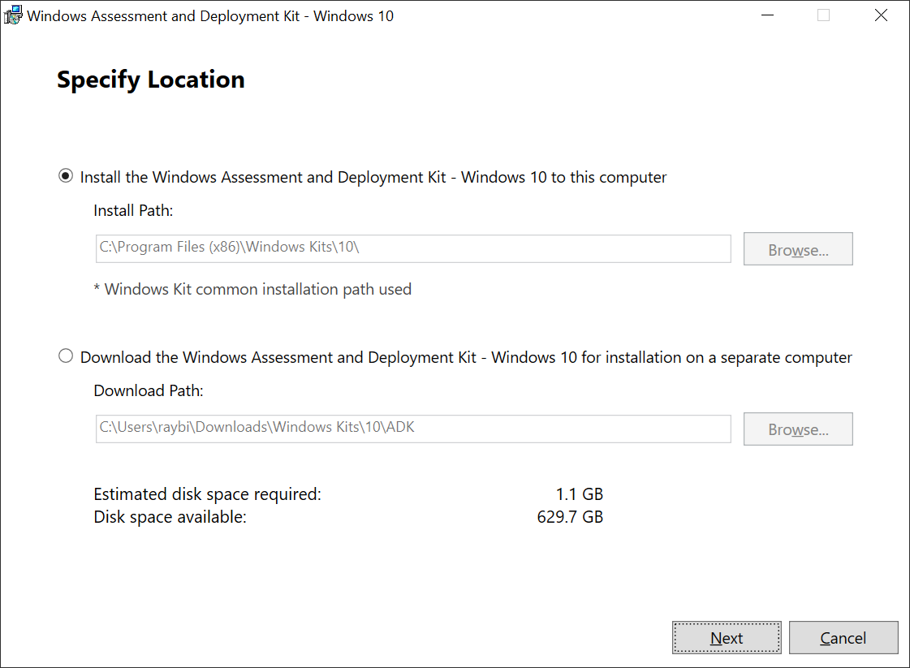

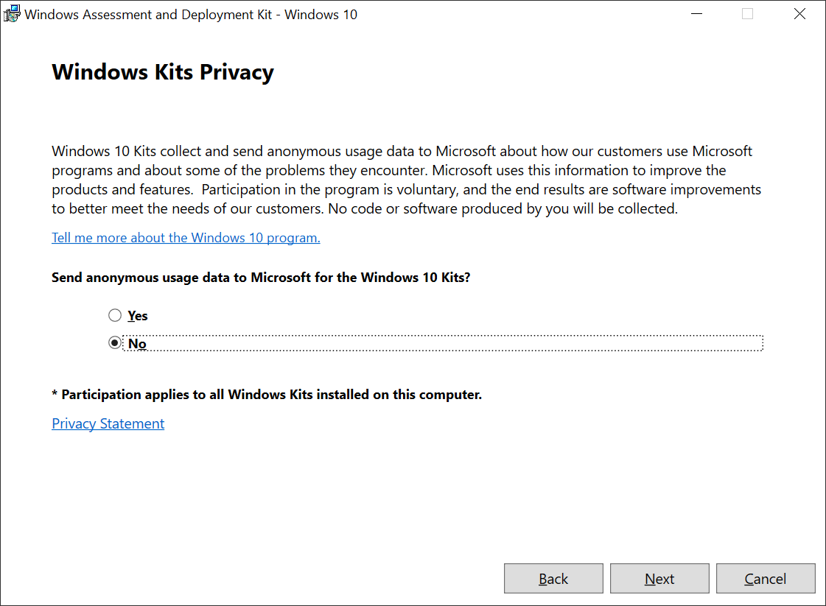

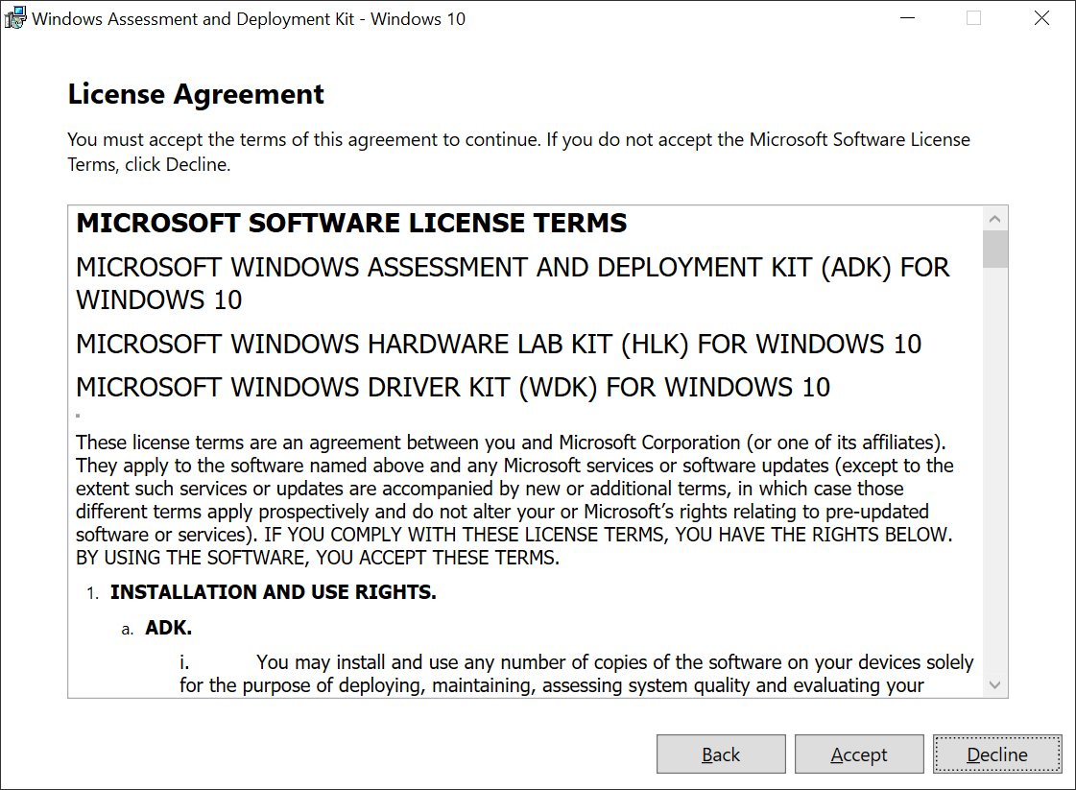

Select

* Windows Performance Toolkit (this includes WPR, WPA and Xperf)
* Windows Assessment Toolkit

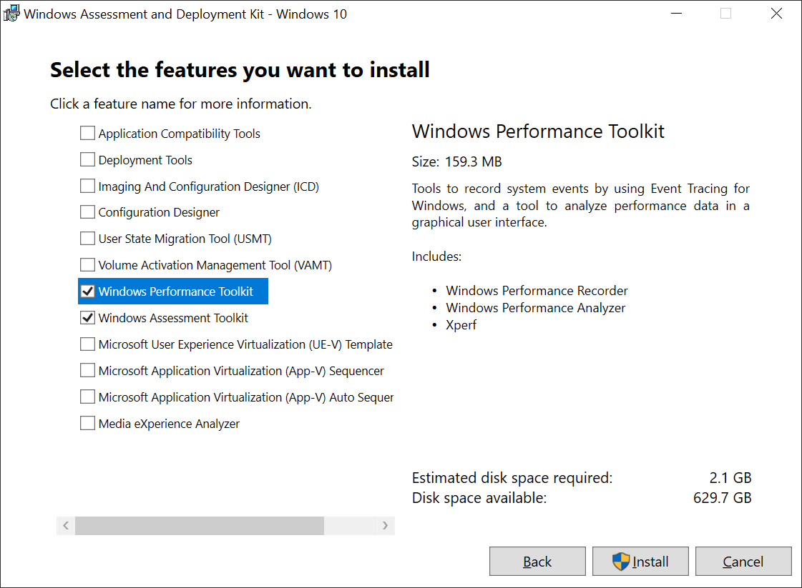

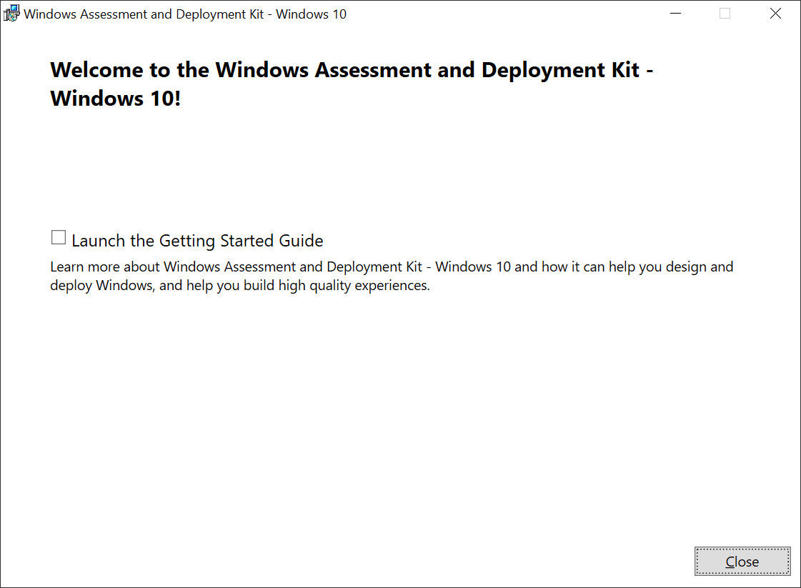

References

1. What’s new in ADK kits and tools

<https://docs.microsoft.com/en-us/windows-hardware/get-started/what-s-new-in-kits-and-tools?redirectedfrom=MSDN>